Assignment 3: End-to-End CI/CD Pipeline Deployment
Student Name: Akshay Ashok More
Project Repo: [https://github.com/Akshaymore2193/velocity-app](https://github.com/Akshaymore2193/velocity-app)
Live URL: [http://35.154.55.208](http://35.154.55.208)
EC2 Instance & Web Server Setup

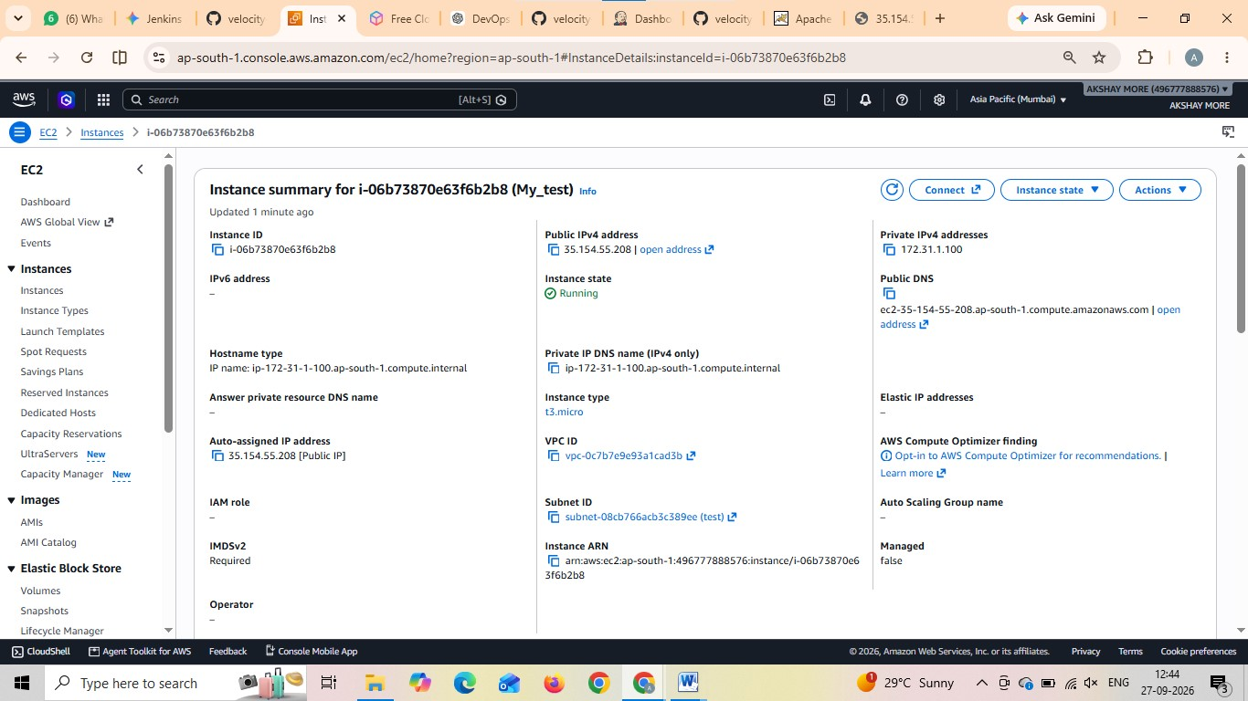

Jenkins Job and Deployment Script Setup
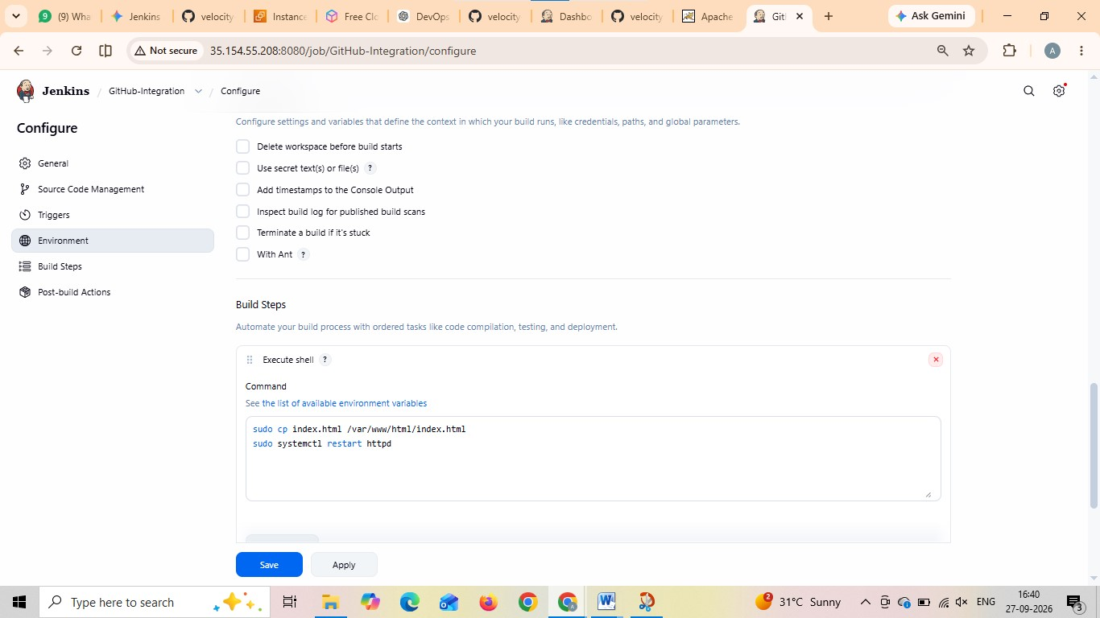

GitHub Webhook Setup

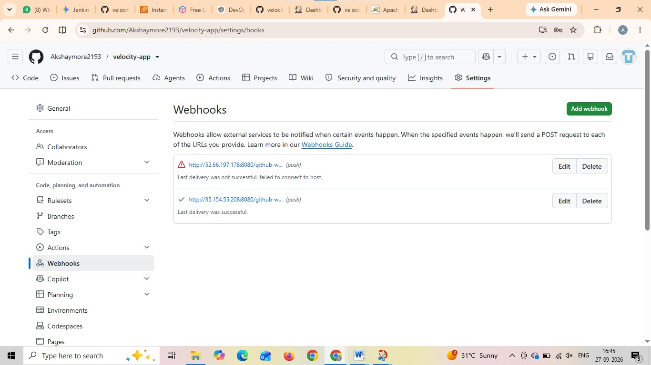

Automated Trigger & Deployment
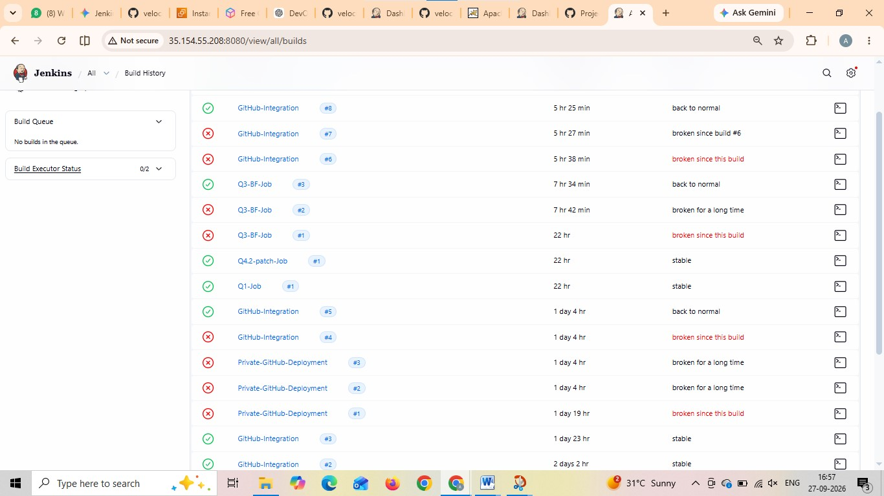

Website Verification
